Stop Dieting. Start Living!

Michelle May, M.D.

Please use the following scale to answer these questions:

Strongly Disagree Disagree Maybe Agree Strongly Agree
1 2 3 4 5

____ I am hungry all the time.
____ I am never hungry.
____ I know I’m not hungry but I eat anyway.
____ I am starving by the time I eat, so I'll eat anything I can get my hands on.
____ I eat by the clock.
____ I think about food all of the time.
____ I love food and eating too much to be a healthy weight.
____ I use food to cope with stress and other feelings.
____ I am an emotional eater.
____ I eat when I’m bored.
____ I reward myself with food.
____ I celebrate every special occasion or milestone by eating.
____ I don’t know why I eat.
____ I often eat until I am stuffed.
____ I have trouble stopping myself when I eat "bad" foods.
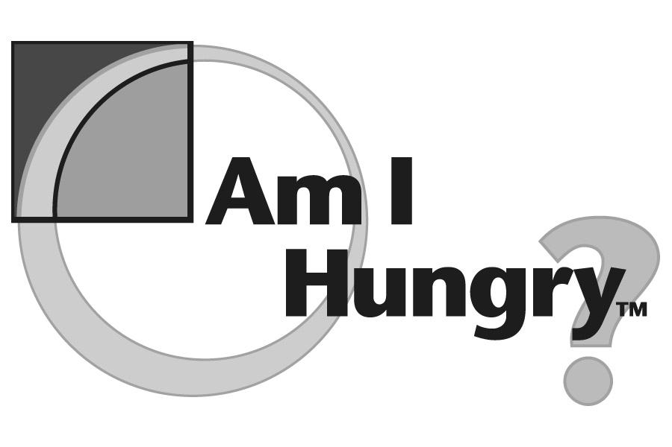
____ I have tried a lot of diets.
____ I am either dieting or eating too much.
____ I feel guilty about eating certain foods.
____ I sometimes ignore hunger in order to control my weight.
____ I avoid certain foods because they are fattening.
____ I am confused about what I should be eating.
____ I hate to exercise.
____ I exercise to control my weight.
____ I dread the thought of going on another diet but I don't know what else to do.

It’s Not About the Food
Look back over your ratings. The statements that you rated a 3 or higher are probably issues that affect your ability to manage your weight effectively and easily. These are some of the tough issues that Am I Hungry? tackles using our unique non-diet approach.

Please visit www.AmIHungry.com
No rules, no deprivation, no sneak eating.

Your Licensed Am I Hungry Workshop Facilitator in UK is Joanne Moller
Telephone: 07547 782740 or Email: joanne@joannemoller.com

